**Online Shop Management System**

**User Story:**

Mrs. Swarna is an entrepreneur. She has her own clothing business. She sells her clothes in both online and. But the problem arises at the month's end when she prepares her sales records. Often, they find mismatches in the accounts. Also, she needs help with online selling. As she takes online orders via phone, she misses calls while taking other orders. For that, she is having fewer orders.

**User Pains Points:**

1. Accounts Mismatch.

2. Missing potential orders.

**Probable Solution:**

1.1. Proper Sales Record System.

1.2. Sales and Online order managing system including delivery.

**Requirement Analysis**

1. User Group:

a. Admin/Shop Owner

c. Sales Person

d. Deliveryman

e. Customer

2. Features:

Common:

* Self Service
* See Profile and Change Password.

Admin:

* Manage Employee
* Manage Customers
* Manage Products
* Manage Orders
* Accounts

Sales Person:

* Assign delivery-man to online sale

Delivery Man:

* Deliver/Return Products

Customer:

* Register to system
* Order products

**Class Diagram**

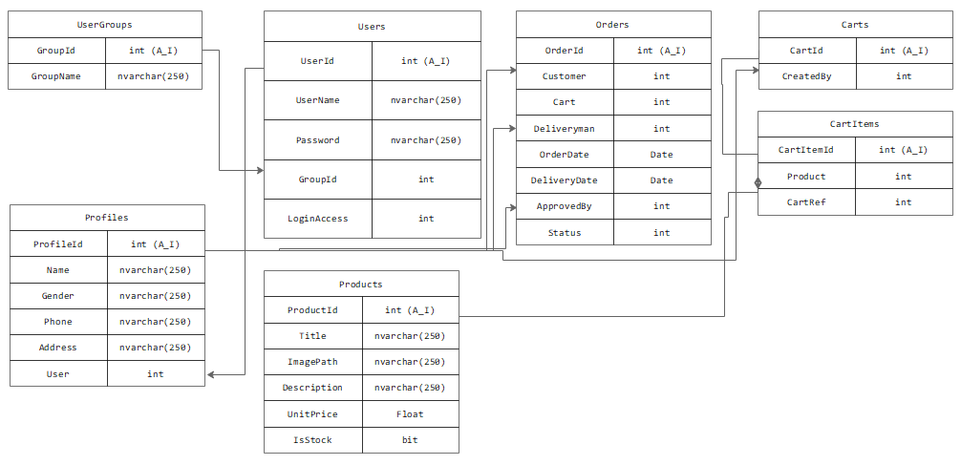

**SQL Query (Opening)**

INSERT

INTO usergroups

(GroupName)

VALUES ("Admin"),

("Manager"),

("Salesman"),

("Deliveryman"),

("Customer");

ALTER

TABLE products

ADD IsStock bit;

INSERT

INTO users

VALUES (

NULL,

'swarna',

'admin123',

'1',

'1'

);

INSERT

INTO profiles

VALUES (

NULL,

'Nabila Islam Swarna',

'Female',

'+8801515217821',

'Motijheel, Dhaka',

'1'

);

CREATE DATABASE `businessdb`;

CREATE TABLE UserGroups (

GroupId int AUTO_INCREMENT PRIMARY KEY,

GroupName varchar(255)

);

CREATE TABLE Users (

UserId int AUTO_INCREMENT PRIMARY KEY,

UserName varchar(255),

Password varchar(255),

GroupId int,

LoginAccess int

);

CREATE TABLE Profiles (

ProfileId int AUTO_INCREMENT PRIMARY KEY,

Name varchar(250),

Gender varchar(255),

Phone varchar(14),

Addess text,

user int

);

CREATE TABLE Products (

ProductId int AUTO_INCREMENT PRIMARY KEY,

Title varchar(250),

ImagePath varchar(255),

Description varchar(14),

UnitPrice float

);

CREATE TABLE Carts (

CartId int AUTO_INCREMENT PRIMARY KEY,

CreatedBy int

);

CREATE TABLE CartItems (

CartItemId int AUTO_INCREMENT PRIMARY KEY,

Product int,

CartRef int

);

CREATE TABLE Orders (

OrderId int AUTO_INCREMENT PRIMARY KEY,

Customer int,

Cart int,

Deliveryman int,

OrderDate date,

DeliveryDate date,

ApprovedBy int,

Status int

);